Program For Problem No. 1

options linesize=80 nodate; run;

data redsox;
input Name$ Position age atbats average hits salary;

cards;
Mirabelli 1 33 163 0.258 42 0.8
Varitek 1 31 451 0.273 123 4.7
Daubach 2 31 183 0.23 42 0.4
Garciaparra 2 30 658 0.301 198 10.5
Millar 2 32 544 0.276 150 2
Mueller 2 32 524 0.326 171 2.1
Ortiz 2 28 448 0.288 129 1.2
Reese 2 30 107 0.215 23 2.5
Shumpert 2 37 84 0.19 16 0.3
Burks 3 39 198 0.263 52 7.2
Damon 3 30 608 0.273 166 7.5
Kapler 3 28 225 0.271 61 3.4
Nixon 3 29 441 0.306 135 4
Ramirez 3 31 568 0.325 185 17.2
;

1.a, 1.b, 1.c

title 'Number of hits predicted by Salary';
proc reg data=redsox;
model hits=salary / clb cli;
run;

plot hits*salary;
run;

1.d, title 'Number of hits predicted by Salary and Age';
proc reg data=redsox;
model hits=salary age / stb scorr1 scorr2;
run;

Output of Program 1a,1b & 1c

Number of hits predicted by Salary 1

The REG Procedure
Model: MODEL1
Dependent Variable: hits

Analysis of Variance

Sum of Mean
Source DF Squares Square F Value Pr > F

Model 1 18694 18694 6.31 0.0273
Error 12 35547 2962.23095
Corrected Total 13 54241

Root MSE 54.42638 R-Square 0.3447
Dependent Mean 106.64286 Adj R-Sq 0.2900
Coeff Var 51.03612

Parameter Estimates

Parameter Standard
Variable DF Estimate Error t Value Pr > |t|

Intercept 1 70.05860 20.58314 3.40 0.0052
salary 1 8.02789 3.19562 2.51 0.0273

Parameter Estimates

Variable DF 95% Confidence Limits

Intercept 1 25.21179 114.90540
salary 1 1.06524 14.99055

Number of hits predicted by Salary 2

The REG Procedure
Model: MODEL1
Dependent Variable: hits

Output Statistics

Dep Var Predicted Std Error
Obs hits Value Mean Predict 95% CL Predict Residual

1 42.0000 76.4809 18.8611 -49.0227 201.9845 -34.4809
2 123.0000 107.7897 14.5532 -14.9614 230.5408 15.2103
3 42.0000 73.2698 19.6995 -52.8438 199.3833 -31.2698
4 198.0000 154.3515 23.9217 24.8178 283.8852 43.6485
5 150.0000 86.1144 16.6842 -37.9172 210.1460 63.8856
6 171.0000 86.9172 16.5301 -37.0164 210.8507 84.0828
7 129.0000 79.6921 18.0743 -45.2607 204.6449 49.3079
8 23.0000 90.1283 15.9626 -33.4515 213.7082 -67.1283
9 16.0000 72.4670 19.9164 -53.8082 198.7422 -56.4670
10 52.0000 127.8594 16.8201 3.7408 251.9781 -75.8594
11 166.0000 130.2678 17.3213 5.8223 254.7133 35.7322
12 61.0000 97.3534 15.0087 -25.6577 220.3646 -36.3534
13 135.0000 102.1702 14.6546 -20.6381 224.9785 32.8298
14 185.0000 208.1384 42.9405 57.0896 359.1872 -23.1384

Sum of Residuals 0
Sum of Squared Residuals 35547
Predicted Residual SS (PRESS) 47466

Output for 1d
Number of hits predicted by Salary and age 5

The REG Procedure
Model: MODEL1
Dependent Variable: hits

Analysis of Variance

Sum of Mean
Source DF Squares Square F Value Pr > F

Model 2 26297 13149 5.18 0.0260
Error 11 27944 2540.37548
Corrected Total 13 54241

Root MSE 50.40214 R-Square 0.4848
Dependent Mean 106.64286 Adj R-Sq 0.3911
Coeff Var 47.26255

Parameter Estimates

Parameter Standard Standardized
Variable DF Estimate Error t Value Pr > |t| Estimate

Intercept 1 314.67808 142.68167 2.21 0.0496 0
salary 1 7.78538 2.96266 2.63 0.0235 0.56934
age 1 -7.73061 4.46869 -1.73 0.1116 -0.37480

Parameter Estimates

Squared Squared
Semi-partial Semi-partial
Variable DF Corr Type I Corr Type II

Intercept 1 . .
salary 1 0.34465 0.32342
age 1 0.14016 0.14016

Reading The SAS output

1a & 1b & 1c. Now focus on salary as a predictor of performance, as measured by number of hits.
- Provide a scatter plot showing the association between these two variables.
Solution:- 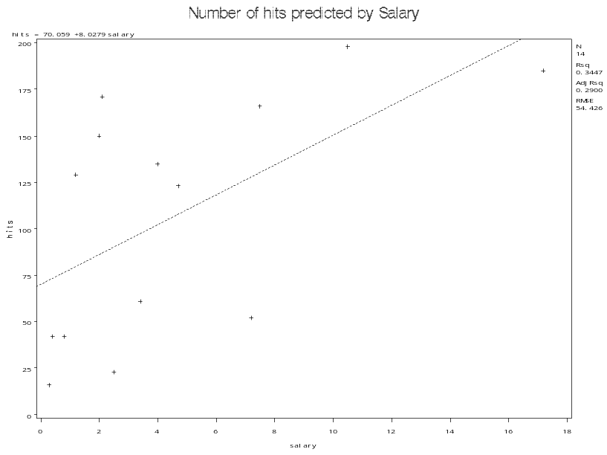

1b. Fit a simple regression model predicting number of hits from salary (do this regardless of whether or not the assumptions of regression are met).
  - How well does salary predict number of hits?
Solution:- Salary is a “moderate” predictor of number of Hits. As from the simple regression the partial R-Square says that Salary explains 34% of the variability for the number of Hits.
  - Is salary a significant predictor of number of hits?
Solution:- As the p-value from the simple regression is < 0.05 , we can conclude at a 95% confidence level that the salary is a significant predictor of number of hits.

  - Find a 95% confidence interval for the slope from this regression, and give an interpretation for both the slope and the 95% confidence interval for the slope.
Solution:- Hits = 8.03 Salary + 70.06.
For each million dollar increase in salary the mean number of hits will increase by 8.
The 95% confidence interval for the slope suggests that the for 1 million dollar increase in Salary the mean number of Hits will increase from some where between 1 and 15.
In other words for one million dollar increase in Salary we will be expecting a mean increase in number of hits which will vary from 1 to 15.

1D.
- Focusing on the regression line as a prediction equation, what is the predicted number of hits for a player with a 2 million dollar salary?
Solution:- Predicted number of Hits are 8.03*2 + 70.058 = 86.

- Find the 95% prediction interval for corresponding to a 2 million dollar salary, and give an interpretation for this interval. Note that Kevin Millar on the Sox made 2 million dollars in 2003 and had 150 hits – how would you evaluate his performance based on this predicted value and prediction interval?
Solution:-
Name | Predicted Value Mean | 95% CL Predict
Millar with 2 million Salary. | 86 Hits in Average | (0, 210)  Note :- No of hits cannot be negative.
Based on the above table Kevin Millar has over performed that means has performed better than what was expected from him.
He has 150 hits in a year, but the predicted value 86 from the simple regression suggests that he has almost scored twice the amount of Hits. Very good performance.
Based on the 95 % confidence interval for the predicted value of 86 hits, Kevin Millar’s average numbers of hits will lie in the interval (0, 210). We are 95% confident that Kevin Millar will score number of hits with is anywhere between 0 and 210. Based on this interval we will not be able to rate Millar’s performance correctly because the confidence interval is too huge. Hence this 95% confidence interval is not a good model to evaluate Millar’s performance.
1d. R^2 = .4848, hence age and salary combined accounts 49% of the variability in no. of hits. We can roughly say that as the players gets older their no. of hits decreases and if salary increases no of hits will increase. Partial R^2 shows that , though 49% is not very good , salary explains most of the variability in no. of hits (32.34%) and the rest is explained by age.

Solution to Problem 2

Analysis of Variance

Sum of Mean
Source DF Squares Square F Value Pr > F

Model 1 4703.718 4703.718 76.54 <.0001
Error 88 5408.070 61.455
Corrected Total 89 10112

Root MSE 7.83935 R-Square 0.4652
Dependent Mean 71.58889 Adj R-Sq 0.4591
Coeff Var 10.95051

Parameter Estimates

Parameter Standard
Variable DF Estimate Error t Value Pr > |t|

Intercept 1 39.03745 3.81140 10.24 <.0001
Juyearmath 1 0.62949 0.07195 8.75 <.0001

